**Affandi (1907-1990)**

Affandi was an Indonesian modernist artist best known for his expressive paintings, which depict scenes of everyday life, his own emotional states, as well as portraits of family members. He is known as the first Indonesian modernist to gain international recognition. Affandi was largely self-taught, and while his work shows strong affiliations with Post-Impressionist and Expressionist tendencies in European art, there is no evidence to show that he studied these movements systematically. Affandi is best known for his technique of applying paint on to canvas directly from the tube and working with his fingers instead of brushes, making for thick impasto and energetic gestural work, which is well-suited to conveying emotionally-charged images. During the period of revolutionary resistance against the Dutch (1945-49), Affandi was painted posters encouraging armed rebellion. He was a founding member of several Indonesian artists’ organisations including Gabungan Pelukis Indonesia (Union of Indonesian Painters), Jakarta, 1948. Throughout his career, spanning the late-colonial and postcolonial periods in Indonesian history, Affandi was officially recognised and celebrated on several occasions by state and academic agencies from Indonesia, India, USA, Singapore and Japan. His final home and studio in Yogyakarta, Indonesia, is now Museum Affandi, featuring a display of his works as well as several eccentric architectural, design and landscape features.

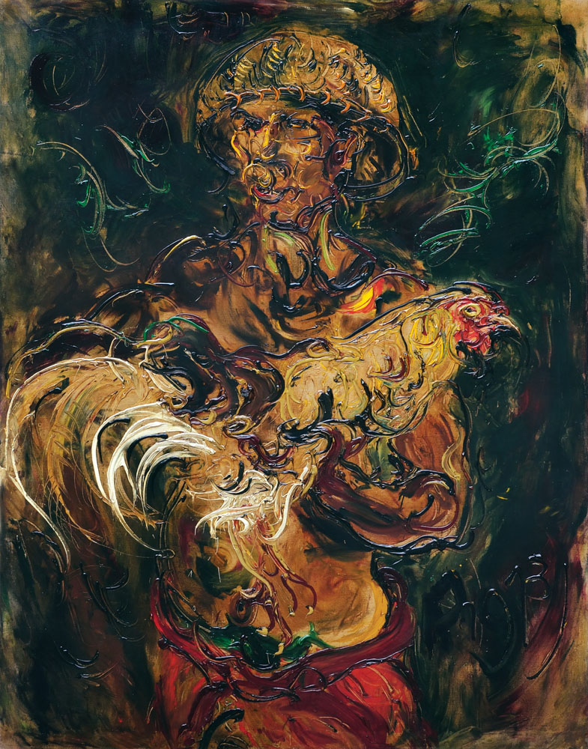

Affandi, *Man with Fighting Cock*, 1973, oil on canvas, 98 x 103 cm, Collection of Oei Hong Dijen, Magelang.

Affandi was born into a family working on a sugar plantation in Cirebon, West Java. His father died while he was young and presumably, he grew up in poverty, dropping out of high school in Jakarta to undertake a number of small-time jobs; he took a teaching post at an evening school, and worked as a ticket collector and poster-painter at local cinemas. In 1935, Affandi joined Kelompok Lima Bandung (Bandung Group of Five), a study-circle of aspiring artists including Hendra Gunawan, Barli, Sudarso and Wahdi. Often created using leftover paints and materials from his poster-painting job, many of Affandi’s early paintings feature images of himself and those of his immediate family (mother, daughter and wife) as models, and depict his straitened circumstances. These portraits vary in medium and style, from delicately impressionistic pastel on paper to more robust oil on panel paintings. Self-portraits indicating particular emotional states can be discerned throughout his career. Recurring images of his mother in are indicative of his ongoing involvement with the matriarch. Affandi’s admiration for *wayang kulit* shadow puppets and Balinese masks, as well as figures in motion is revealed by the recurrence of them in his work.

After receiving a scholarship from the Indian government, Affandi spent 1949-51 in India, based primarily at Santiniketan, West Bengal. However, he also travelled around the country holding solo exhibitions in Bombay (Mumbai) as well as in Allahabad, New Delhi and Madras (Chennai). During 1951-54 he exhibited his work in Latin America and Europe, representing Indonesia at biennials in Sao Paulo (1953) and Venice (1954). A string of national and academic honours followed. From his first solo exhibition in 1943, until his 1987 retrospective, which were both held in Jakarta, Affandi remained a prolific painter deeply interested in humanist ideals.

**Refernces and Further reading**

---- (1999) *Affandi*, (exhibition catalogue) Fukuoka: Fukuoka Asian Art Museum.

Fischer, Joseph, ed. (1990) *Modern Indonesian Art*:*Three Generations of Tradition and Change 1945-1990.* Jakarta and New York: Panitia Pameran KIAS and Festival of Indonesia.

M. Agus Burhan. (2012) *Masterpieces of the Indonesia National Gallery*. Jakarta: Indonesia National Gallery.

Spanjaard, Helena. (2004) *Exploring Modern Indonesian Art: the collection of Dr Oei Hong Djien*. Singapore: SNP Editions.